T-TEST GROUPS=group(1 2)
/MISSING=ANALYSIS
/VARIABLES=frequncy axialratio
/ES DISPLAY(TRUE)
/CRITERIA=CI(.95).

T-Test

Notes
Output Created |  | 06-MAR-2021 14:21:06
Comments
Input | Active Dataset | DataSet0
Input | Filter | <none>
Input | Weight | <none>
Input | Split File | <none>
Input | N of Rows in Working Data File | 33
Missing Value Handling | Definition of Missing | User defined missing values are treated as missing.
Missing Value Handling | Cases Used | Statistics for each analysis are based on the cases with no missing or out-of-range data for any variable in the analysis.
Syntax |  | T-TEST GROUPS=group(1 2)  /MISSING=ANALYSIS  /VARIABLES=frequncy axialratio  /ES DISPLAY(TRUE)  /CRITERIA=CI(.95).
Resources | Processor Time | 00:00:00.02
Resources | Elapsed Time | 00:00:00.03

[DataSet0]

Group Statistics
 | group | N | Mean | Std. Deviation | Std. Error Mean
frequncy | withoutslot | 16 | 2.6250 | .23805 | .05951
frequncy | withslot | 16 | 2.6250 | .23805 | .05951
axialratio | withoutslot | 16 | 37.0751 | 10.96832 | 2.74208
axialratio | withslot | 16 | 47.3525 | 38.66077 | 9.66519

Independent Samples Test
 |  | Levene's Test for Equality of Variances |  | t-test for Equality of Means
 |  | F | Sig. | t | df
frequncy | Equal variances assumed | .000 | 1.000 | .000 | 30
frequncy | Equal variances not assumed |  |  | .000 | 30.000
axialratio | Equal variances assumed | 20.899 | .000 | -1.023 | 30
axialratio | Equal variances not assumed |  |  | -1.023 | 17.399

Independent Samples Test
 |  | t-test for Equality of Means
 |  | Sig. (2-tailed) | Mean Difference | Std. Error Difference | 95% Confidence Interval of the Difference
 |  |  |  |  | Lower
frequncy | Equal variances assumed | 1.000 | .00000 | .08416 | -.17188
frequncy | Equal variances not assumed | 1.000 | .00000 | .08416 | -.17188
axialratio | Equal variances assumed | .315 | -10.27739 | 10.04664 | -30.79536
axialratio | Equal variances not assumed | .320 | -10.27739 | 10.04664 | -31.43696

Independent Samples Test
 |  | t-test for Equality of Means
 |  | 95% Confidence Interval of the Difference
 |  | Upper
frequncy | Equal variances assumed | .17188
frequncy | Equal variances not assumed | .17188
axialratio | Equal variances assumed | 10.24059
axialratio | Equal variances not assumed | 10.88219

Independent Samples Effect Sizes
 |  | Standardizerª | Point Estimate | 95% Confidence Interval
 |  | Standardizerª | Point Estimate | Lower | Upper
frequncy | Cohen's d | .23805 | .000 | -.693 | .693
frequncy | Hedges' correction | .24421 | .000 | -.675 | .675
frequncy | Glass's delta | .23805 | .000 | -.693 | .693
axialratio | Cohen's d | 28.41619 | -.362 | -1.058 | .340
axialratio | Hedges' correction | 29.15215 | -.353 | -1.031 | .332
axialratio | Glass's delta | 38.66077 | -.266 | -.961 | .438

a. The denominator used in estimating the effect sizes.
Cohen's d uses the pooled standard deviation.
Hedges' correction uses the pooled standard deviation, plus a correction factor.
Glass's delta uses the sample standard deviation of the control group.

* Chart Builder.
GGRAPH
/GRAPHDATASET NAME="graphdataset" VARIABLES=group MEANSD(frequncy, 1) MEANSD(axialratio, 1)
MISSING=LISTWISE REPORTMISSING=NO
TRANSFORM=VARSTOCASES(SUMMARY="#SUMMARY" INDEX="#INDEX" LOW="#LOW" HIGH="#HIGH")
/GRAPHSPEC SOURCE=INLINE.
BEGIN GPL
SOURCE: s=userSource(id("graphdataset"))
DATA: group=col(source(s), name("group"), unit.category())
DATA: SUMMARY=col(source(s), name("#SUMMARY"))
DATA: INDEX=col(source(s), name("#INDEX"), unit.category())
DATA: LOW=col(source(s), name("#LOW"))
DATA: HIGH=col(source(s), name("#HIGH"))
COORD: rect(dim(1,2), cluster(3,0))
GUIDE: axis(dim(3), label("group"))
GUIDE: axis(dim(2), label("Mean"))
GUIDE: legend(aesthetic(aesthetic.color.interior), label(""))
GUIDE: text.title(label("Clustered Bar Mean of frequncy, Mean of axialratio by group by INDEX"))
GUIDE: text.footnote(label("Error Bars: 95% CI"))
GUIDE: text.subfootnote(label("Error Bars: +/- 1 SD"))
SCALE: cat(dim(3), include("1", "2"))
SCALE: linear(dim(2), include(0))
SCALE: cat(aesthetic(aesthetic.color.interior), include(
"0", "1"))
SCALE: cat(dim(1), include(
"0", "1"))
ELEMENT: interval(position(INDEX*SUMMARY*group), color.interior(INDEX),
shape.interior(shape.square))
ELEMENT: interval(position(region.spread.range(INDEX*(LOW+HIGH)*group)),
shape.interior(shape.ibeam))
END GPL.

GGraph

Notes
Output Created |  | 06-MAR-2021 14:21:46
Comments
Input | Active Dataset | DataSet0
Input | Filter | <none>
Input | Weight | <none>
Input | Split File | <none>
Input | N of Rows in Working Data File | 33
Syntax |  | GGRAPH  /GRAPHDATASET NAME="graphdataset" VARIABLES=group MEANSD(frequncy, 1) MEANSD(axialratio, 1)  MISSING=LISTWISE REPORTMISSING=NO  TRANSFORM=VARSTOCASES(SUMMARY="#SUMMARY" INDEX="#INDEX" LOW="#LOW" HIGH="#HIGH")  /GRAPHSPEC SOURCE=INLINE.  BEGIN GPL  SOURCE: s=userSource(id("graphdataset"))  DATA: group=col(source(s), name("group"), unit.category())  DATA: SUMMARY=col(source(s), name("#SUMMARY"))  DATA: INDEX=col(source(s), name("#INDEX"), unit.category())  DATA: LOW=col(source(s), name("#LOW"))  DATA: HIGH=col(source(s), name("#HIGH"))  COORD: rect(dim(1,2), cluster(3,0))  GUIDE: axis(dim(3), label("group"))  GUIDE: axis(dim(2), label("Mean"))  GUIDE: legend(aesthetic(aesthetic.color.interior), label(""))  GUIDE: text.title(label("Clustered Bar Mean of frequncy, Mean of axialratio by group by INDEX"))  GUIDE: text.footnote(label("Error Bars: 95% CI"))  GUIDE: text.subfootnote(label("Error Bars: +/- 1 SD"))  SCALE: cat(dim(3), include("1", "2"))  SCALE: linear(dim(2), include(0))  SCALE: cat(aesthetic(aesthetic.color.interior), include(  "0", "1"))  SCALE: cat(dim(1), include(  "0", "1"))  ELEMENT: interval(position(INDEX*SUMMARY*group), color.interior(INDEX),  shape.interior(shape.square))  ELEMENT: interval(position(region.spread.range(INDEX*(LOW+HIGH)*group)),  shape.interior(shape.ibeam))  END GPL.
Resources | Processor Time | 00:00:02.16
Resources | Elapsed Time | 00:00:01.18

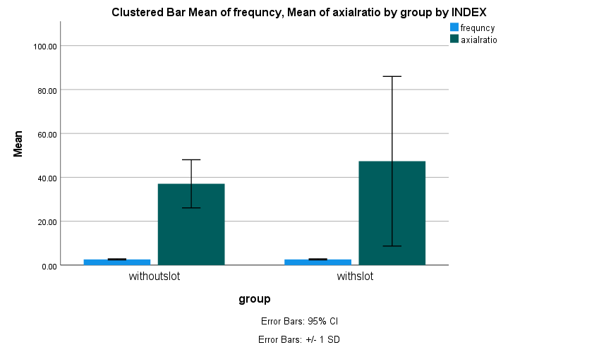

DATASET ACTIVATE DataSet0.
DATASET ACTIVATE DataSet0.

SAVE OUTFILE='E:\final year projects\circular patch 2.4GHz projects\project4\spss graph\DataSet '+
'axial ratio.sav'
/COMPRESSED.
DATASET ACTIVATE DataSet0.

